Enable configuration for system ready iot

This section tells you how to enable the following configuration options required for SystemReady IR - IoT certification requirements:

UEFI support with U-Boot

* Device Firmware Update to enable UpdateCapsule support
* UEFI support with U-Boot

### Enable UEFI support with U-Boot

Enable the configuration options in root_workspace/u-boot/configs/platform_name_defconfig as shown in the following code:

CONFIG_BOOTM_EFI=y CONFIG_CMD_BOOTEFI=y CONFIG_CMD_NVEDIT_EFI=y CONFIG_CMD_EFIDEBUG=y CONFIG_CMD_GPT=y CONFIG_EFI_PARTITION=y CONFIG_EFI_LOADER=y CONFIG_EFI_DEVICE_PATH_TO_TEXT=y CONFIG_EFI_UNICODE_COLLATION_PROTOCOL2=y CONFIG_EFI_UNICODE_CAPITALIZATION=y CONFIG_EFI_HAVE_RUNTIME_RESET=y CONFIG_CMD_EFI_VARIABLE_FILE_STORE=y

Add the configuration options to enable the UEFI UpdateCapsule() interface to update firmware as follows:

CONFIG_CMD_DFU=y CONFIG_FLASH_CFI_MTD=y CONFIG_EFI_CAPSULE_FIRMWARE_MANAGEMENT=y CONFIG_EFI_CAPSULE_FIRMWARE=y CONFIG_EFI_CAPSULE_FIRMWARE_RAW=y CONFIG_EFI_CAPSULE_FMP_HEADER=y

So we did the changes accordingly in the u-boot config

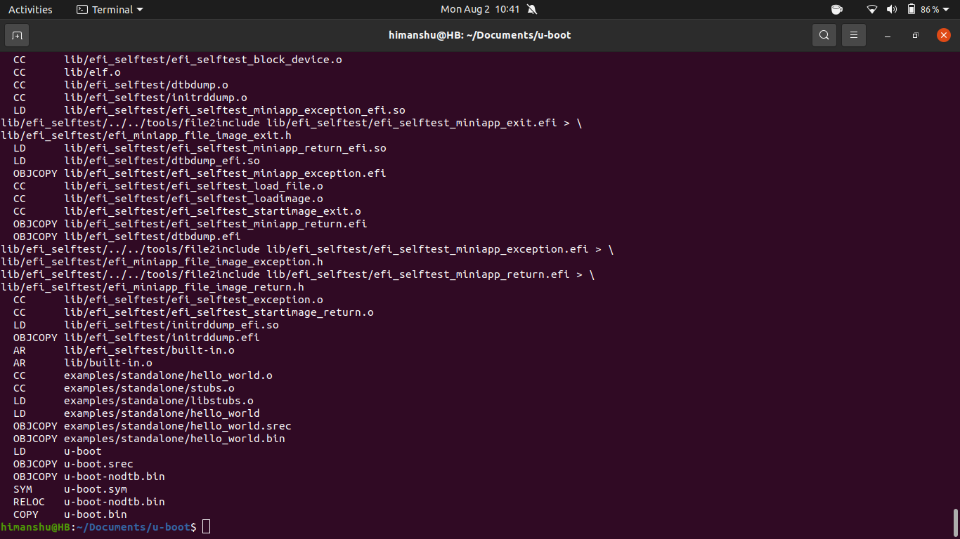

also you can save that config using the commands

**make savedefconfig**

**cp defconfig arch/arm/configs/my_cool_defconfig**

**CONFIG_BOOTM_EFI=y** # enable bootm command to launch FIT image with UEFI binary

**CONFIG_CMD_BOOTEFI=y** # command bootefi to lauch UEFI binaries

**CONFIG_CMD_NVEDIT_EFI=y** # commands to display and edit UEFI variables

**CONFIG_HEXDUMP=y** # required for display of UEFI variable content; CONFIG_SPL_HEXDUMP is not needed

**CONFIG_CMD_EFIDEBUG=y** # command to edit boot options

**CONFIG_CMD_GPT=y**  # command to display and alter GUID partition table

**CONFIG_EFI_PARTITION=y** # partition table support

**CONFIG_EFI_LOADER=y** # enable UEFI sub-system

**CONFIG_EFI_DEVICE_PATH_TO_TEXT=y** # provide EFI_DEVICE_PATH_TO_TEXT_PROTOCOL

**CONFIG_EFI_UNICODE_COLLATION_PROTOCOL2=y** # provide FI_UNICODE_COLLATION_PROTOCOL2

**CONFIG_EFI_UNICODE_CAPITALIZATION=y** # support lower/upper conversion for non-ANSI characters

**CONFIG_EFI_HAVE_RUNTIME_RESET=y** # enable reset runtime service at runtime

**CONFIG_CMD_EFI_VARIABLE_FILE_STORE=Y** # store UEFI variables in file, if OP-TEE StandAloneMM is available choose EFI_MM_COMM_TEE instead

**CONFIG_EFI_SECURE_BOOT=y** # enable secure boot

